Activity 2: UML Diagram Design Project

Title: Boarding House Management System

The Boarding House Management System is a digital solution designed to improve the efficiency of managing boarding house operations. Currently, the boarding house relies on manual record-keeping, which leads to problems such as lost tenant information, difficulty in tracking payments, delayed maintenance responses, and confusion in room availability. These issues result in poor management and inconvenience for both the administrator and tenants.

To solve these problems, the proposed system will automate tenant registration, payment tracking, room management, and maintenance requests. It provides a centralized platform where the administrator can manage all operations, while tenants can easily view their billing status and request repairs. This system will improve accuracy, save time, and enhance overall service quality.

Actors / Users
- Administrator
Manages the entire system
- Registers tenants
- Assigns rooms
- Records payments
- Handles maintenance requests
- Generates reports

- Tenant
- Views billing and payment history
- Submits maintenance requests
- Checks room and account status

Main System Functions
- User login and profile management
- Tenant registration
- Room assignment and status update (Available/Occupied/Maintenance)
- Payment recording and billing tracking
- Maintenance request submission and monitoring
- Notification system (due payments, updates)
- Report generation (revenue, occupancy, tenant status)

UML Diagram (Use Case Diagram)
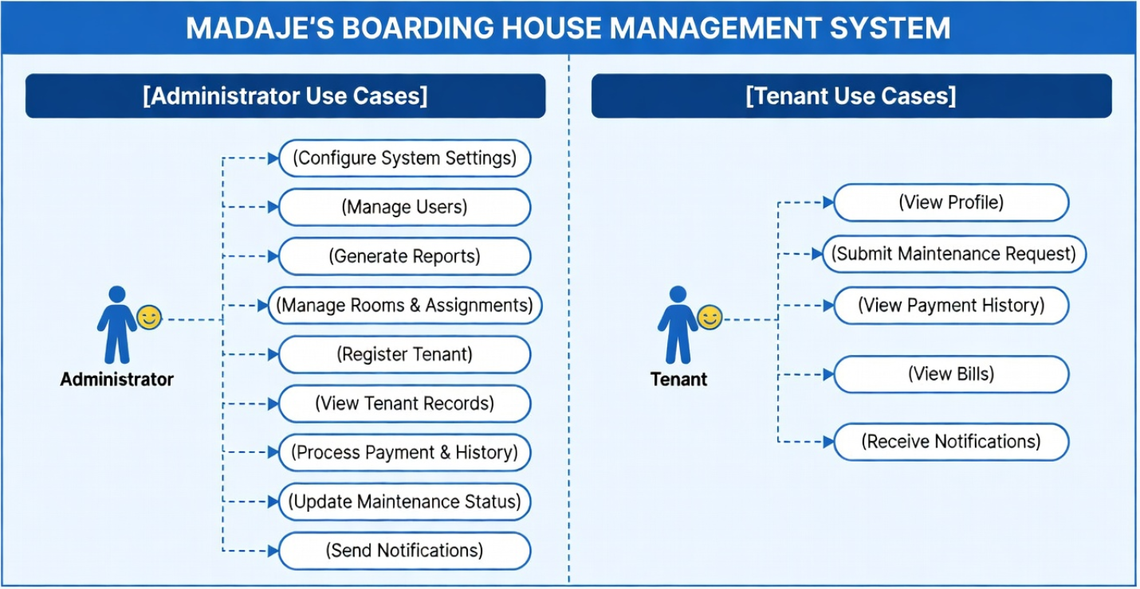

Explanation
The Use Case Diagram shows how the Administrator and Tenant interact with the Boarding House Management System. The Administrator handles most of the system operations, including managing tenants, rooms, payments, and maintenance. Meanwhile, the Tenant has limited access, mainly for viewing billing information and submitting maintenance requests. This diagram clearly illustrates the responsibilities of each actor and how the system supports daily operations. Overall, it helps visualize how the system improves efficiency and organization.

